**Abstract:**

One of the latest developments that have been happening in Ireland’s energy sector is the introduction of an Integrated Market for Trading Electricity, which can be also thought of as a Wholesale market for purchasing Electricity, which completely redefined the Electricity market in Ireland and Northern Ireland. The market which is known as the *Integrated Single Electricity Market (I-SEM)* started its operation on October 1st,2018.[1&2] This market has incorporated the all-Island and European Electricity markets which have eased the flow of energy (Electricity and Gas) across borders. The trade market mainly functions through these three Primary markets: *The Day-Ahead-Market (DAM), the Intra-Day-Market, and the Balancing Market.*

In this paper, we will discuss the peak and off-peak hours of the spread of electricity throughout the day on an hourly basis and consequently, the *electricity arbitraging opportunities.* [16] for load shifting and storage depend on wind and demand forecasts. The arbitraging process is facilitated by the introduction of batteries which are economical given they can be implemented at both small and large scale. [16,17]

In the following report, we will be exploring the predictor variables in our dataset which are Wind Forecast (WF), Demand Forecast (DF), and Delivery Period, and our target variable is EURPrices (Euros/hr). Incorporating Renewable Energy Sources (RES) is a fundamental element of Europe’s plan to cut carbon emissions by at least 55% by 2030, compared to 1990 levels. [7]. Optimal control of decentralized energy systems can be achieved by using the prediction model of RES, which allows grid operators, users, and owners to make informed decisions.[6].

The purpose of the project is to analyze Negative Pricing in the Irish Electricity Market and find solutions with better predictability of demand of power and forecast of wind power with the implementation of large-scale grid batteries for energy storage and to balance the demand and supply in the market. Minimizing market risks and maximizing profits are the main objectives of the market participants.

**Index**

**Abstract**

**Chapters:**

1. **Introduction to Market**5

1.1 Overview and Types of Markets5

1.2 Day-Ahead-Market (DAM)6

1.3 Intra-Day-Market (IDM)7

1.4 Balancing Market (BM)7

1.5 Capacity Market8

1.6 ISEM Market Dataset8

1.6.1 Demand Forecast8

1.6.2 Wind Forecast9

1.6.3 DAM Price10

2. Correlation between the Variables12

2.1 Overview12

2.2 Non-positive Pricing14

2.3 Seasonality, Cycles and Trends in data14

2.4 Variation of Wind and demand Forecast on weekly basis16

2.5 Hourly Variations17

3. Data Preparation and Model Building18

3.1 Exploratory Data Analysis (EDA)18

3.2 Skewness and Kurtosis in Python18

3.3 Regression in Python20

3.4 Seasonality and Trend Analysis23

3.5 Normalization24

4. Electricity Storage26

4.1 Arbitrage under Perfect and Imperfect Foresight 27

4.1 Battery Energy Storage System 28

4.3 Features of Batteries 28

**5**. **Conclusion**32

**6**. **References**33

**CHAPTER 1**

**Introduction to Market**

* 1. **Overview and Types of Markets**

Electricity is a commodity with idiosyncratic properties such as non-storability, requirement between demand and supply, demand inelasticity, issue of transportability and seasonal behavior. The Energy Market in Ireland has evolved manifolds in the last 40 years and one of the latest developments has been the Wholesale Trading of Electricity, which is creating a common platform for purchasing and selling Electricity by consumers and generators respectively. Although electricity prices can appear unpredictable in their behaviour, *Singh et al*. [11] state that they are non-random in nature making it possible to identify underlying patterns and periodicities based on historical data and forecasts. It is extremely important to understand the market requirements for participants on either side of the trade as they are responsible for delivering or consuming the amount of energy that they have submitted into the market. Extreme price volatility, which can be up to two orders of magnitude higher than that of any other commodity or financial asset, has forced market participants to hedge not only against *volume risk* but also against *price movements*. Hence, Forecasting will play a crucial role to understand the supply-demand to capture the best prospects the market has to offer and avoid exposure to volatile prices and price shocks.

Another factor that is important to take into account is the dependency on the fossil fuels such as coal, oil and natural gas around the world which is a matter of grave concern. The total dependency on non-renewable resources accounts for approximately 67%. The green-House-gases generated have been a menace for the earth leading to an increase in temperature by 15 degrees Celsius because of the gaseous cover around the earth which mostly comprises of carbon-di-oxide (CO2). Thus, we may increase our dependency of the production of electricity from Renewable Energy Resources. Globally, Renewable Energy sources account for 29% of the entire electricity generation as of 2020 [5] with *Solar and Wind* becoming the “New Normal”.

The term “*Integrated Single Electricity Market”* was first coined in November 2007, [7] when an SEM was established in the Republic of Ireland and Northern Island. ISEM began its operations by the end of 2018. The SEM (Single Electricity Market) is jointly regulated by the Utility Regulator and the Commission of Energy Regulation (CER). The decision body that governs the market is the *SEM Committee (SEMC).*

The introduction of ISEM has increased the level of competition which has helped to put downward pressure on the prices along with transparency in the process of purchase and supply [10]. Generators and consumers can trade electricity at prices agreeable to both by bidding in the market, which is facilitated by the *Market Operators.* Market Operators ensure fair trade, reliable exchange of electricity and money, and determine prices based on the bids submitted. The introduction of the system has led to an increased number of opportunities for participants as they could now trade in multiple time-frames, maximizing the efficient use of interconnectors for Balanced Market (BM), optimal use of resources and most importantly, secure the trading practices and the interests of both the generators and consumers, new opportunities, Customer data and agility and, Risk and rewards for large energy consumers [5].

The committee comprises of three distinct areas that provide revenue streams relating to services provided by the participants of the market i.e., the Energy Trading Arrangements (ETA), the Capacity Remuneration Mechanism (CRM) and the Delivering a Secure Sustainable Electricity System. The SEMC is broken down between the *Day-Ahead Market (DAM), Intra-Day Market (IDM) and the Balancing Market (BM)* [8].

How are the market prices decided?

A power station is paid for the generation of electricity in two ways, The Marginal Cost of Production (to cover the cost of labor, fuel, storage capacity and maintenance) and Annual Capacity Payments (to cover the cost of the infrastructure of the power station) for providing the generation capacity to the grid (*also known as the Transmission system*). Suppose, a Power plant wants to sell 100 MWh of electricity for 30 Euros/MWh at a particular time of the day and depending upon the demand, the bids are ordered in ascending order which is selected for production till the total energy demand is met. Apart from the bid price, the power generators are also paid *Annual Capacity Payments* to enable them to cover the capital costs of the building. At *low levels of demand*, the generators *supply electricity at a low marginal cost.*

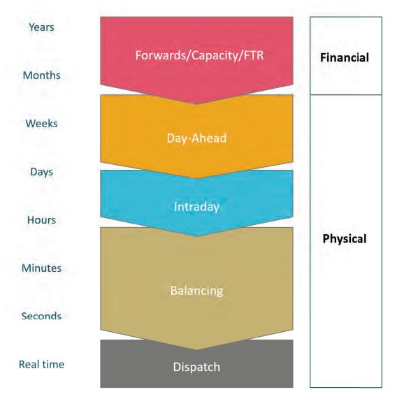

**Fig 1.1: Hierarchy of the Market Operations. (Source: Eirgridgroup.com)**

* 1. **Day-Ahead-Market (DAM)**

In Day-Ahead-Market (DAM) the bidding happens a day prior to the delivery of electricity. The Day of Delivery (Delivery Period) is divided into multiple blocks of equal durations and for each block, the bidding is done separately and market prices are determined independently. The ‘Bid’ includes the price and quantity of electricity (MWh). The market opens 19 days (D-19) prior to delivery and closes at 11 am the Day (D) before the auction takes place.

In DAM, the market participants trade electricity in 24-one-Hour Trading brackets from the time frame starting at 23:00 (D) and finishing the trading at 23:00(D+1).[1]. The period from 23:00 (D) to 23:00 (D+1) is known as *Trading* *Period*.

**1.3 Intra-Day-Market (IDM)**

The Intra-Day Market functions the same as Day-Ahead Market, the only difference is that it provides the traders the flexibility to adjust their bidding time as the market conditions fluctuate near real-time (delivery time). It is a continuous trading platform between day-ahead and Balancing markets, allowing to correct original schedules for example, Power outages or changes in wind power generation.[5] The IDM is open till 1 hour prior to delivery. It takes care of any unplanned power outages or interconnectors. The trading period duration for each auction at Intra-day Market is 30 minutes. The Market opening (*Order Book Opening*) for the 48 half-hourly Trading periods in a trading day will open at 11:45 am a day prior to the trading day.[1]

The IDM comprises of the following three daily auctions:

***IDA-1****:* The auction starts at 17.30 daily. The delivery order booking opens at 23:00 (same day) to 23:00 (next day). The trading period is 24 hours

***IDA-2****:* The auction starts at 08:00 daily. The delivery order booking opens at 11:00 (same day) to 23:00 (same day). The trading period is 12 hours

***IDA-3****:* The auction starts at 14:00 daily. The delivery order booking opens at 17:00 (same day) to 23:00 (same day). The trading period is 6 hours

**1.4 Balancing Market (BM)**

The Balancing Market is the arrangement that establishes market-based balance management in the unbundled electricity trading market.[14]. The primary service offered by the BM is to keep the Transmission System balanced by keeping the supply of energy equal to the demand of energy with the sellers even earning profit. For example, if the demand of electricity is higher than expected, the TSO (*Transmission System Operator*) will instruct a generator that has the available capacity to increase its output. [5]. It is close to real-time operation for the system operator to ensure power system balance. At each point of time, the total production must be equal to the total consumption in order to stabilize the system frequency, it is therefore also called as *Frequency Control*. The TSO takes control over the BM one hour prior to delivery. Similar to the Intra-Day Market the Delivery periods at the Balancing Market is divided into 48 (30 mins) *Imbalance settlement periods.* The flagging and tagging process is used to determine the initial imbalance price in the initial 5 mins of the imbalance settlement period.

*What is Positive and Negative Pricing?*

When the supply more or less reflects the Cost of Production and as this cost is positive, the meeting point between supply and demand should be a Positive Price. On the contrary, when the Generators pay Consumers to offload their power i.e. there is a *significant production surplus*.

To deal with the problem of Electricity Surplus production, Large scale Electricity storage is still difficult (the electricity storage or reservoir having limited capacity), the surpluses are exported to Interconnection capacities.[15]

*Note*: A participant’s Net energy position is the cumulative volume of all the trades in the *ex-Ante Markets (DAM and IDM)* and finally balancing any difference in the supply-demand which is taken care in the BM.

**1.5 Capacity Market**

“Capacity” is not actual Electricity but rather the ability to produce electricity when called upon several years in the future. The Capacity market involves a System operator whose job is to ensure that sufficient generation capacity is present for reliable system operation in the near future at competitive prices. This market allows for the recovery of fixed costs. The auctions are run a minimum of 1 year ahead before the capacity is needed. The overall costs of these payments are distributed among the suppliers.

This market pays generators who are available to meet the electricity demands when they are at their peak. The Capacity market is designed to ensure that the generation capacity in Ireland and Northern Island (including storage, Demand side Units and Interconnector Capacity) is sufficient to meet the demand and the regulatory approved *Generation Adequacy* standard is satisfied.[8]

**1.6 ISEM Data**

With the study of the Wind and power forecast data modern-day transmission systems are more reliable and secure. The non-linear nature of wind speed is a challenge to forecasting using traditional methods.

**1.6.1 Demand Forecast**

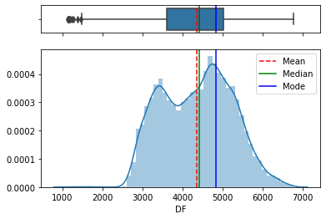

**Fig 1.2.1** Probability Distribution of Demand Forecast: Bimodal Distribution

**Descriptive Statistics of the Demand Forecast in the ISEMData:**

count 30696.000000

mean 4358.773995

std 869.253853

min 1142.000000

25% 3607.000000

50% 4415.000000

75% 5021.000000

max 6764.000000

Fig 1.2.1 shows the Probability distribution of the Demand Forecast data(observation) is a Bimodal Distribution. It represents two local maximums, meaning there are two different groups or two most frequently repeated values. In the context of the probability distribution, modes are peaks in the distribution. The higher apex on the right side is the *major mode* and the lower is the *minor mode*. The data does *not* typically fit into the Normal (Gaussian) Distribution by design and the presence of *no fair gap or distinct gap* between the two peaks indicates it is close to Normal Distribution bell-shaped curve. We cannot separate the bimodal distribution into two uni-modal distributions. It is a good case for using the *non-parametric kernel density estimation (KDE) method*. The Mean and Mode (Measures of Central Tendency) are not near common values in this distribution.

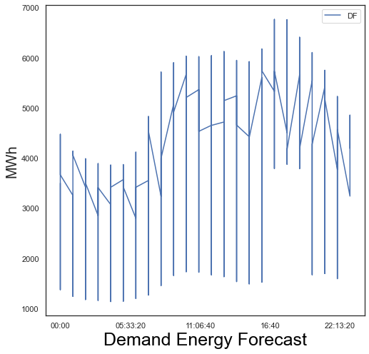

**Fig 1.2.2 Demand Forecast: Hourly Basis**

Fig 1.2.2 shows the frequency in the hourly trend shows peaks two times (maximums, Fig 1.2.1) in a day, also shown in the Bi-modal distribution, first at around 11 am and next at early evening around 5 pm though there is not much gap between the two peaks. It can still be considered a *fairly symmetric distribution.*

**1.6.2 Wind Forecast**

The wind Forecast is produced 24 hours ahead of delivery. Below fig 1.3.1 shows that the Wind Forecast data is Right-skewed or positively skewed, meaning most of the data is falling on the right and positive side of the graph’s peak. The distribution is asymmetric. The Mean, Median, and Mode are all different (Mean>Median>Mode). Right-skewed data indicates a lower boundary in a dataset meaning the dataset’s lower boundaries are extremely low relative to the rest of the data.

**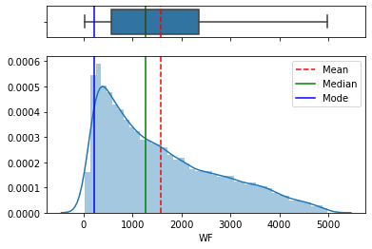  
Fig 1.3.1: Wind Forecast – Distribution of data**

**Descriptive Statistics of the Wind Forecast in the ISEMData:**

count 30696.000000

mean 1570.685513

std 1185.294924

min 24.905000

25% 573.554250

50% 1265.832500

75% 2353.052000

max 4984.441000

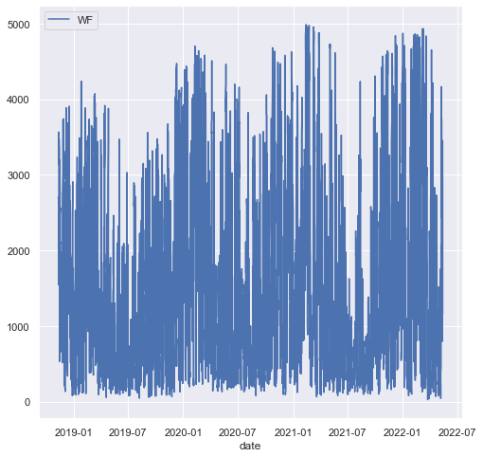

**Fig 1.3.2:** **Plotting Wind Forecast: Hourly basis**

**Fig 1.3.2**

**1.6.3 Day-ahead Market Prices (/MWh)**

The below plot shows the time-series variation of the daily Day-ahead Market Price (Euros/MWh) in Ireland. The data extends from *2018-11-11* till *2022-05-13*.

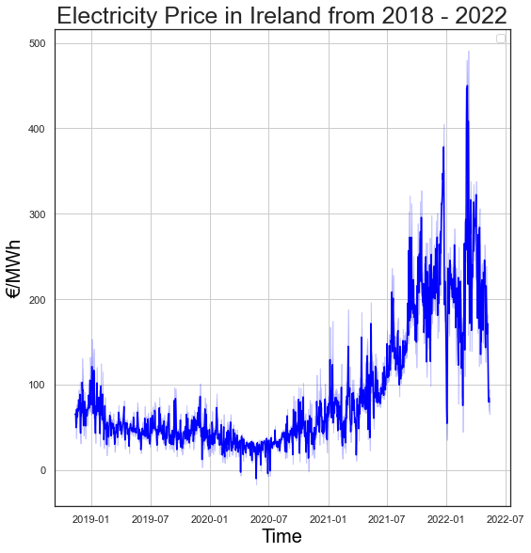

**Fig 1.4: DAM Prices variation over the years**

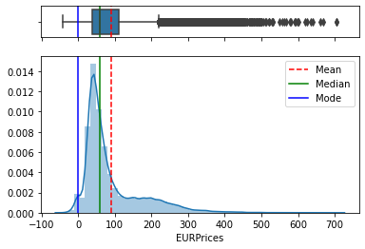

**Fig 1.5: Data Distribution: DAM Prices**

The above graph shows that the price slightly dipped in 2020 from 2019 but has been rising steeply since then to the peak reaching in around February-March 2022

We will cover more about the distribution of the data in chapter 3 (Skewness and Kurtosis)

**CHAPTER 2**

**Correlation between the variables**

**2.1 Overview**

In this chapter, we will analyse the characteristics of the Day-ahead Market such as Volatility, Seasonal Trends, and patterns.

During the last 10 years, the size and complexity of the European Day-Ahead Markets have grown substantially. The spot market reached a record volume of 577 TWh in 2019.[20] & EPEXSPOT 2020. The markets are constantly evolving and bringing new challenges to the market participants. A wind energy power plant is able to generate more electricity on a windy day while a solar power plant is more efficient on sunny days.

With the increasing nature of complexity in bidding structures, there has been a dire need of optimization techniques to clear the day-ahead markets. For Example, in Turkey, the DAM clearing problems include more than 15000 orders out of which nearly are block orders [21]. The European Day-ahead market is more complex

Amongst the three trade markets, DAM is the main spot market and is used to determine the electricity market for the next day and has some of the most distinct features such as seasonal trends, volatility, and non-positive pricing.

Ireland experiences four seasons over the year which are Spring (March-April-May) with temperatures ranging from 4-10, Summer (June-July-August) having a temperature range of 10-18, Autumn (September-October-November) with a temperature range of 10-17 and Winter (December-January-February) with a temperature range of 3-7

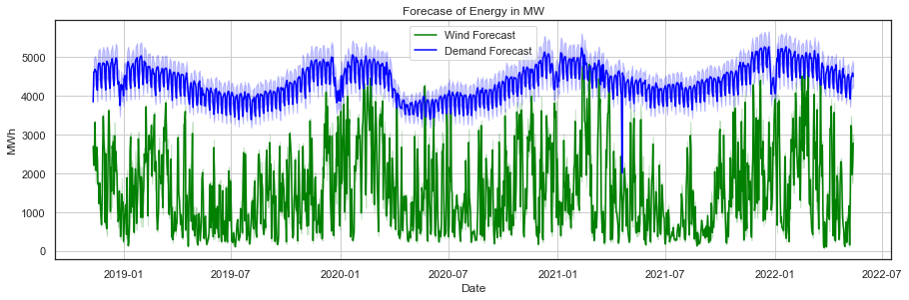

**Fig 2.1: Comparing the Wind Energy and the Demand in MW on daily basis**

In Fig 2.1, we can see that the energy demand is always higher than the wind energy available. A better view would be Fig 2.3 which shows the wind and demand on monthly basis.

If the wind energy forecast is approximately 70% of the Demand forecast then:

* Industrial users like data centres can charge batteries for later use.
* Consumers can program their electric appliances to run over those particular hours such as Charging their Electric or Hybrid cars etcetera. On a very windy Irish day forecast: the best time to charge batteries is between 1-4 am and around 3 pm

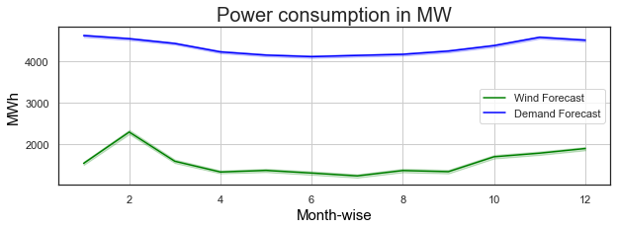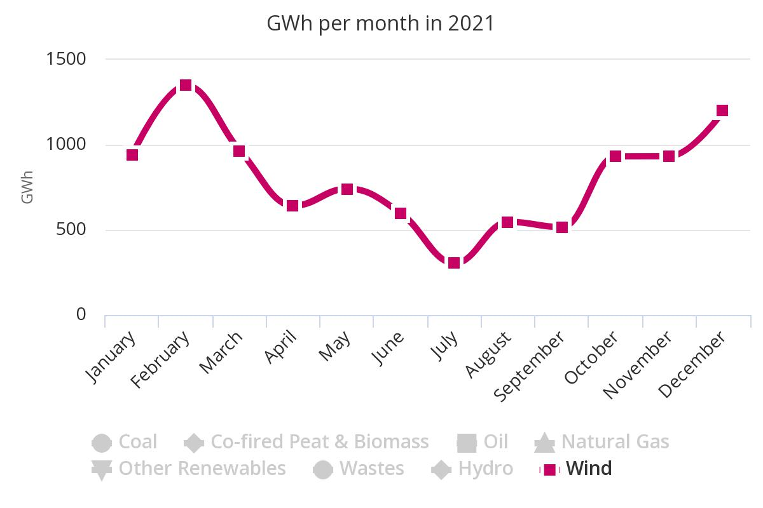

**Fig 2.2 Month-wise Demand and Wind Fig 2.3 Month-wise Demand and Wind. (Source:[3])**

As mentioned earlier, the electricity demand varies with day and season, the demand is always higher side in the start of every year. The overall energy demand covered by wind generation is 36% in Ireland. [23]. The windiest month in Ireland are January and February

The wind forecast reaches its peak at the beginning of every year and so does the demand.

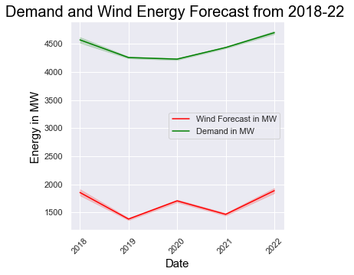

**Fig 2.3: Yearly Demand and Wind Forecast from 2018-2022**

**2.2 Non-positive Pricing in Day-ahead Market**

The cost of electricity is highest in the evening in the Day-ahead market.

Let’s discuss the characteristic ‘*Non-positive Pricing’* in the Day-ahead market and how it influences Market pricing. Under the I-SEM, which is designed to boost efficiency and align Irish Energy costs more closely to that in Europe, all generators including Wind companies, have to price and sell electricity 12 to 24 hours ahead (DAM) of actual delivery. However, sometimes it is difficult for the Wind companies to accurately predict the output 12 to 24 hours ahead.

For example, during the Coronavirus Pandemic in **2020**, Ireland witnessed Negative pricing [23] as the market could not use as much as power was generated and that means the consumers were being paid by the generators to consume power, and generators were charged for producing it. The peak levels of the wind output outplaced the reduced levels of power demand as we can see in Fig 2.2.

The solution to reduce the frequency of negative power is the storage of electricity and technologies that provide services that do not produce active power that we will discuss in the next chapter.

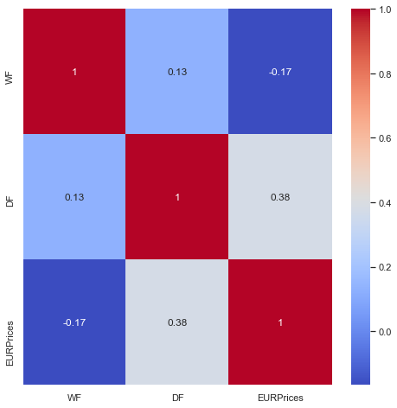

**Fig 2.4: Correlation between the Wind Forecast, Demand Forecast and Day-Ahead Market Prices (red-high, blue-low)**

Considering Prices as the Response and Wind Forecast and Demand Forecast as predictors, we can see from Fig 2.4 that there is a *Strong* *Negative* correlation between Wind Energy Forecast and DAM Prices and a *Moderately* *Positive* Correlation between Demand and DAM Prices.

We will discuss more about the correlation between the response and predictors in Chapter 3

**2.3 Seasonality, Cycles, and Trend in data**

We will be studying the seasonal changes or variations in the data with the help of plotting in python’s seasonal_decompose package. The first subplot is the data over time, the second subplot is the *Trend* which is the *varying mean over time*, the third subplot is *Seasonality* which is *changing variance over time* and the last subplot is the *Residual* (Trend *minus* Seasonality).

**Wind Forecast:** The following plot is the combination of different subplots to understand the variable, in this case, *Wind Forecast over time* showcasing the trend, seasonal and residuals*.* Thepatterns in all the subplots are stationary (explained in Chapter 3 under section 3.4), as there are no constant visible changes in the pattern and is constant with each point in time.

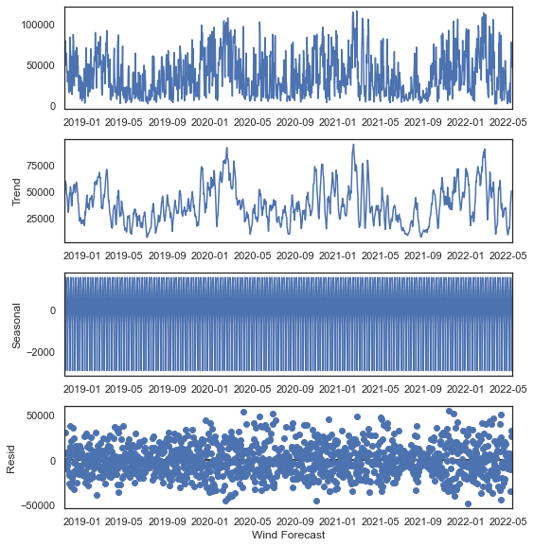

**Fig 2.5 Seasonality and Year-wise Trend of Wind Forecast**

**Demand Forecast:** 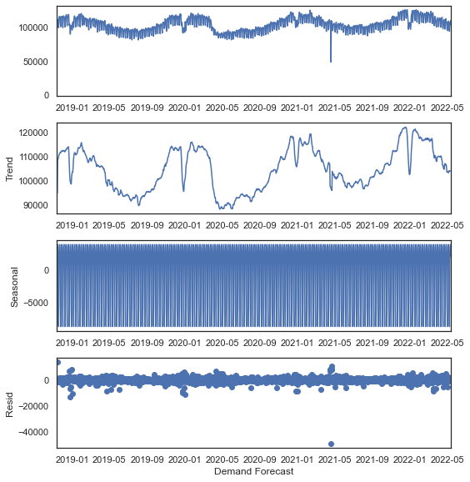

**Fig 2.6 Seasonality and Year-wise Trend of Demand Forecast:**

The Demand is consistent over the years. The first subplot in Fig 2.6 is the *Level* which shows the average value in the series, The *Trend* shows the increasing or decreasing values in the series which in this case, is constant over time. *Seasonal* is the repeating short-term cycle in the series, hence the data is stationary with time and no visible variation in pattern.

**Day-ahead Market Prices** :

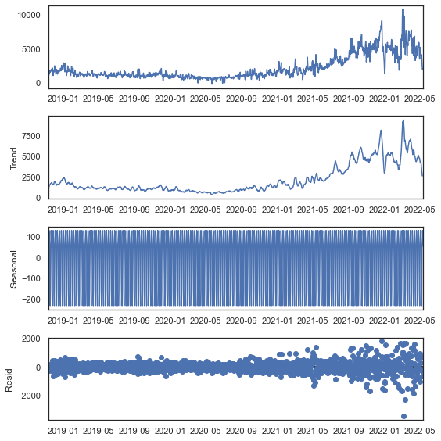

**Fig 2.7 Below figure shows the Seasonality and Year-wise Trend of the Day Ahead Market Price**

The above graph (Level, Trend, Seasonal and Residuals) shows that the electricity prices have been stable from 2018 till the mid of 2021, however, the electricity prices start rising sharply from mid of 2021 till 2022, which is in sharp contrast to the Trend of Wind and Demand Forecast where there has been no steep jump or downfall. There is an increase in variance in the data of DAM Prices over time.

**2.4 Variation of Demand and Wind Forecast on a Weekly basis**

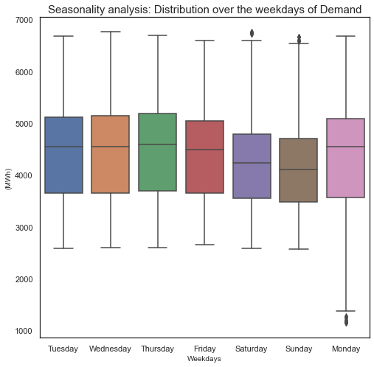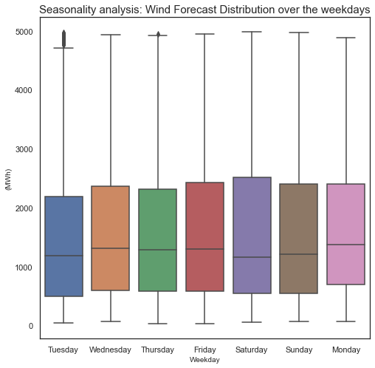

**Fig 2.8: Wind and Demand Forecast: Weekly basis**

Fig 2.7 shows the demand and wind forecast over the each day of the week. The demand for energy is high on Mondays while the Wind Forecast is stable and similar throughout the week. The demand is high on Mondays because of the increase/ surge in activities after the weekend such as charging of vehicles, getting ready for work and preparing for the week ahead.

**2.5 Hourly Variations:**

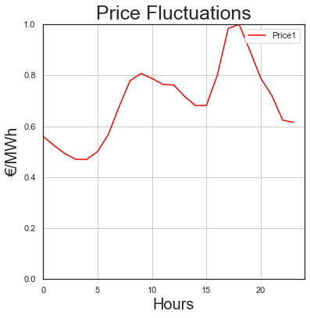

**Fig 2.9: Hourly Price Fluctuations: Price levels are highest in the early night period (around 5-6 pm) and lowest in the early morning (around 3-4 am)**

The prices are high because of the increase in demand in the early night as people are returning to homes after work and light up their homes and prepare dinner, so all gadgets are in use. Demand and prices are low in the early morning, around 3-4 am because of the low requirement for consumption.



**Fig 2.10 Wind and Demand of energy on an hourly basis (24 hours)**

Fig 2.9 and 2.10 shows that Demand and Price are in-line with each other which is confirmed by Fig 2.4 (Correlation matrix) which shows that Demand and DAM Price are moderately *positively* *correlated* while Wind and DAM Prices are strongly negatively correlated which indicates that there might be a presence of price volatility.

**CHAPTER 3**

**Data Preparation and Model Building**

This chapter will give an overview of the dataset used and the methods used to model the data and how we interpret and draw insights from them which can be helpful to improve the model further.

**3.1 Exploratory Data Analysis (EDA)**

EDA is a crucial step. It gives an overview of the dataset and its features, its uniqueness and anomalies, and finally summarise the characteristics of the dataset for us. Once we have successfully imported the packages, we import the dataset. Data pre-processing and Exploratory Data analysis was done using Python Data and Analysis Library. The dataset was converted into “.csv” format, then imported using the read_csv() function of pandas. Classify the columns as *Categorical*, *Ordinal* or *Numerical*/*Continuous*.

**Categorical variables** are those variables that can be classified or categorized into definite groups, for example, Gender (Male/Female/Other), Marital status (Yes/No), Employed (Yes/No) etcetera. **Ordinal Variables** are ordered groups such as ranking of cities per population, ranking high to low as per the marks scored by students in a class. **Numerical** **or** **Continuous variables** are those variables that can take any value in a range. We have 3 numerical/continuous variables in our dataset i.e. ‘Wind Forecast’, ‘Demand forecast’ and ‘DAM Price’. The input variables were converted from object datatype to float64 datatype for better analysis. The “DeliveryPeriod” variable which is a DateTime timestamp was further manipulated into ‘date’, ‘day’, ‘week’, ‘month’, ‘year’ for better analysis using python’s DateTime library. The dataset values range from *11-11-2018* to *13-05-2022*.

In this dataset, we will consider Wind Forecast (WF) and Demand Forecast (DF) as *Predictors* or Independent variables and DAM Prices (EURPrices) as the *Response* or the Dependent variable.

Forecasting time series data is different to other forms of Machine Learning problems because the time series data often is correlated with the past. That is, present value is influenced by past value which is knowfloat64 n as “*Autocorrelation” (correlating with self).*

The correlation coefficient varies between -1 and 1. The continuous variables in the dataset i.e., *Wind Forecast, Demand Forecast* and *DAM Price* are correlated with each other. We have shown the relation between the variables using the *Correlation* *Matrix*.

**3.2 Skewness and Kurtosis in Python**

To understand the distribution of data per variable better, we have calculated skewness and kurtosis in python. *Skewness* is the statistical measure of asymmetric distribution of data while *Kurtosis* helps to determine if the distribution is heavy or light-tailed.[31].

A Normal or gaussian distribution indicates the ideal distribution of data in the form of a bell-shaped curve. A normal distribution might get distorted because of significant factors.

*Distribution of Skewness:*

* Skewness = 0, when the distribution is normal
* Skewness>0 or positive, when the distribution is right-tailed
* Skewness<0 or negative, when the distribution is left-tailed

Skewness=

where is mean, and ‘s’ is standard deviation.

Kurtosis of a Normal Distribution is a measurement of Frequency Distribution by providing insight into the shape of distribution.

*Measurement* *of* *Kurtosis:*

* Kurtosis = 3, where the Distribution is normal
* Kurtosis<3, it is platykurtic
* Kurtosis>3, it is Leptokurtic

Kurtosis =

where is the mean, ‘n’ is the total number of observations and ‘S’ is the standard deviation.

|  |  |  |
| --- | --- | --- |
|  | **Skewness** | **Kurtosis** |
| **Wind Forecast (WF)** | 0.79451087 | 2.67828578 |
| **Demand Forecast (DF)** | 0.02951092 | 2.19608496 |
| **DAM Prices (EURPrices)** | 1.80438880 | 6.69053944 |

**Table 3.1: Skewness and Kurtosis in variables calculated using python’s stats package in scipy module**

*Wind Forecast*: Skewness is positive (0.7945), which is in the range 0.5 to 1, indicating it is moderately skewed, the data distribution is right-tailed which we have also seen in Fig 1.3.1 with a Kurtosis~=3, showing the distribution is curve is close to normal distribution.

*Demand Forecast:* Skewness is very low indicating nearly ‘Normal Distribution’ which we have explained with Fig. 1.2.1 and 1.2.2. Kurtosis is 2.196 indicates that the bell-shaped curves are slightly lower than the Normal-distribution curve.

*DAM Prices*: We have calculated the Skewness and Kurtosis of the variables to interpret their distribution. Amongst the three variables, “EURPrices” is **highly skewed**.

Earlier in Fig 1.2.1, we have seen the non-parametric probability distribution Kernel Density Estimation (KDE) of the “Demand Forecast” Variable. Our aim is to build a smooth Probability Density Function.

Assuming we have a set of N samples xi = {x1, x2,……,xN}, the KDE, , of the PDF is defined as:

is the scaled version of the kernel. The parameter h of the kernel is called the bandwidth and this coefficient is important in the critical determination of the estimate’s quality.

Basically, **in the kernel density estimation approach, we centre a smooth scaled kernel function at each data point and then take their average**. One of the most common kernels is the Gaussian kernel:

K(u) =

**3.3 Regression in Python Language:**

Python is an interpreted, high-level programming language for general-purpose programming (Python, 2018). In Python language, Linear Regression or *Ordinary Least Squares* (OLS) regression framework, is the most commonly used statistical model where the dependent variable is called the “*target*” and the independent variables are the “*features*”. The intercept and the slopes are the parameters of the regression. The parameters are chosen by defining an error function for a given line (in case of a single feature) and choosing the one that minimizes the function. A *Loss Function* is defined as the function that minimizes the *Residual Squares.* The regression estimates a coefficient ‘ai’ for each independent variable. Large coefficients result in “*Overfitting*” which can be mitigated by regularization; the large coefficients are penalized.

‘Statsmodel’ is a Python library designed for statistical-based approach to data analysis. It integrates well with *numpy* and *pandas* libraries. It provides the access to various statistical tests required to check the quality of the fit and a dedicated set of plotting functions to visualize and diagnose th fit.

We have hourly price profiling reflecting the daily variations of the wind forecast, demand and cost, the model has to be implemented across all 24 hours, thus producing 24 set of parameters

The ISEM Dataset used to learn the patterns is called the training set and the training error is called the loss function. If the model overfits on the training data, it may not generalize well on future data because the model’s performance depends on how the data is split. To avoid overfitting, Cross-validation (CV) may be implemented.

**Linear Regression and Ordinary Least Squares:**

Linear regression is the most commonly used modelling technique. It makes very strong assumptions about the relationship between the predictor variables (WF(X1) and DF(X2)) and the response (EURPrices/Y). we can define the relationship as follows:

Y= β0 + β1*X1 +β2 *X2

Ordinary Least Squares is the simplest and most common estimator in which the two βs are so chosen so as to minimize the square of the distance between the predicted values and the actual values. This model is useful where the goal is to understand the simple model in detail; it is computationally cheap to calculate the coefficients (βs) and easier to interpret the data.

The resulting model can be represented as:

+ *X1 + *X2,

Where the caps on the variables (Y) represent the predicted data. The βs are the parameters of the model, where β0 is the *intercept (constant term).*

We import the *statsmodels.api* and we take the response variable (Y) and X1 and X2 and store it separately as follows:

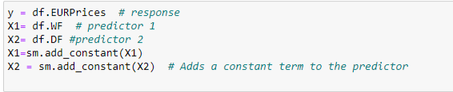



**Fig 3.1 Assigning values to variables**

Now we perform the regression of the predictor on the response, using the *sm.OLS* class and its initialization OLS(y,X) method. This method takes as an input two array-like objects: X and y. In general, X will either be a NumPy array or a pandas data frame with shape (n,p) where n is the number of data points and p is the number of predictors. y is either a one-dimensional numpy array or a pandas series of length n.

Then, we need to fit the model by calling the OLS object’s fit() method.

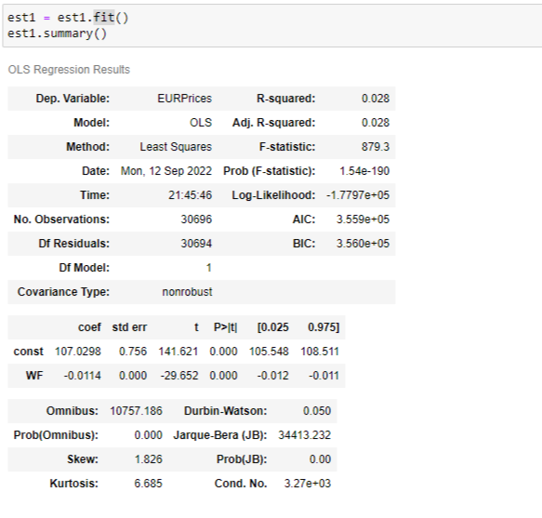  
**Fig 3.2: Applying the Least Squares method to understand the relationship between WF and Prices**

The coefficients of the fit are: **constant:107.0298 and WF: -0.0114, R-sq :0.028**

Next, using the %pylab inline we pick 500 equally spaced points from min to max of the WF predictor to calculate the predicted values using scatter plot to show the actual data and the red line is the regression line, showing moderately negative relation between the Wind forecast and DAM Price.

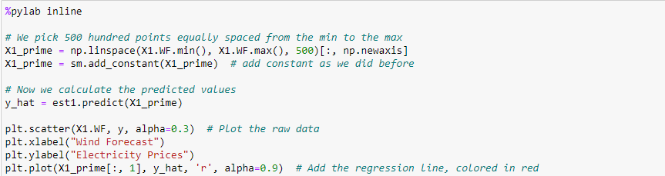

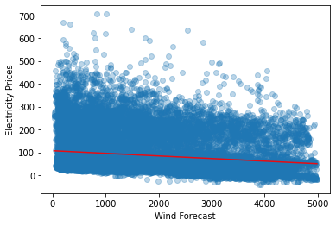

**Fig 3.3 Linear Regression Line :WF(predictor) and EURPrices(response)**

We perform the same process with our response (‘EURPrices’) and predictor (‘Demand Forecast’)

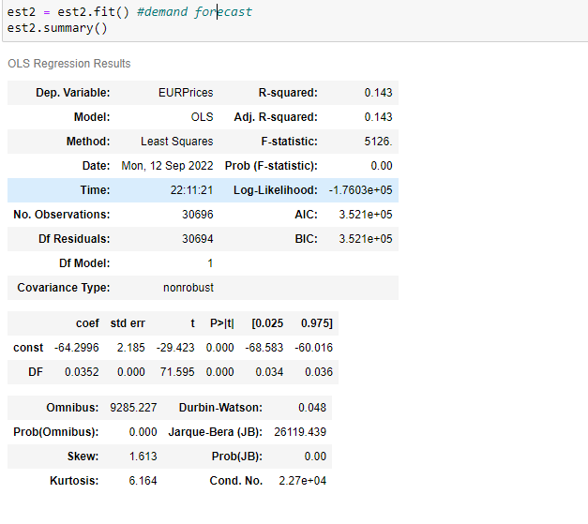  
**Fig 3.4: Applying the Least Squares method to understand the relationship between DF and Prices**

The coefficients of the fit are: **constant:-64.2995 and DF: 0.0352, R-sq:0.143**

We perform a similar process by selecting 500 equally spaced points from min to max of the Demand Forecast (DF) predictor to calculate the predicted values using scatter plot to show the actual data and the red line is the regression line, showing a moderately positive relationship between the Demand forecast and DAM Price.

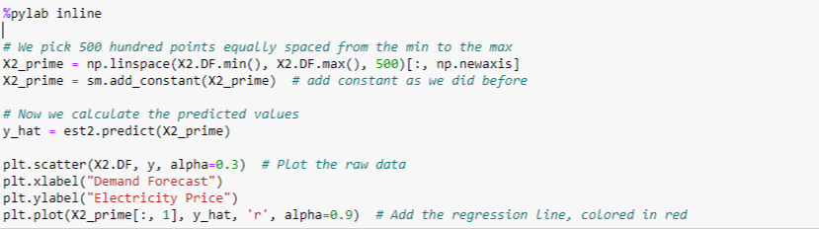

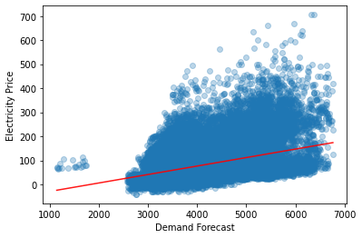  
**Fig 3.5 Linear Regression Line: DF (predictor) and EURPrices (response)**

**3.4 Seasonality and Trend Analysis**

Seasonality Decomposition is the combination of factors that affect the data. (As we have seen in Fig 2.5,2.6 and 2.8). Traditional Machine Learning problems treat each data point ‘independently’ while time-series data is about trends, patterns and predictions.

**Data** = **Level** (Average Values in the series) + **Trend** (Increasing / Decreasing values in

the series) + **Seasonality** (Repeating patterns) + **Noise** (Random variables/Outliers)

Since renewable energy is not continuous, steady and has random probability in distribution, accurate modeling of the uncertainties in them is the solution. Time series scenarios can be an approach to study the uncertainties in renewable resources. With the use of a set of possible power generation scenarios, renewable producers and system operators are able to take decisions forecasting the variables and their characteristics such as stochastic economic dispatch/unit commitment, optimal operation of wind and storage systems and trading strategies. A precise forecast is needed to overcome the gaps in power generation caused by fluctuations in weather conditions.

**Data Stationary Analysis using Augmented Dickey-Fuller Test**

|  |  |  |  |
| --- | --- | --- | --- |
| **Results of Dickey fuller test** | | | |
| **p-value = 0.00 (Stationary data)** | | | |
|  | **WF** | **DF** | **EURPrices** |
| **Test Statistic** | -14.185569564925 | -11.536935652464 | -4.7127592590300 |
| **p-value** | 1.895534549729136e-26 | 3.713754531797238e-21 | 7.962905147372187e-05 |
| **Lags used** | 50 | 51 | 48 |
| **Observations** | 30645 | 30644 | 30647 |
| **Critical Value(1%)** | -3.431 | -3.431 | -3.431 |
| **Critical Value(5%)** | -2.862 | -2.862 | -2.862 |
| **Critical Value(10%)** | -2.567 | -2.567 | -2.567 |

**Table 4.2: Test statistics of the variables**

*Statistical significance of the variables:*

H0: Null Hypothesis, states that there is no relationship between two or more variables

Ha: Alternate Hypothesis, The independent variables did affect the dependent variable.

p-value or the probability values indicates the level of significance between 0 and 1. Smaller the p-value, higher the chance to reject the null hypothesis.

A p-value less than 0.05 is statistically significant, thus indicating that we should reject the Null hypothesis and accept the Alternate Hypothesis meaning there is a strong relationship between the variables. The p-value of all the variables is ~0.00(<0.05), hence the series is Stationary, meaning the series is independent of time and there is strong relationship between the variables.

*The R-squared* is a metric for goodness-of-fit measure for regression models. R-square measures the strength between the model and the dependent variable.

R2 =

However, R-squared value is NOT always an ideal metric to predict if the regression model provides an adequate fit to the data. Sometimes, low R-sq values can be perfectly good models, such as in case where variation is high and the variables are statistically significant. In the ISEMdata, all the variables are statistically significant i.e. they are dependent on each other (Fig 4.2 and 4.4).

**3.5 Normalization**

Using min-max scaler the data is normalized to get rid of the dependencies of scales.:

Xnorm(i) =

Normalization is the process of casting data into a definite range like between 0 and 1 or between -1 to 1. Normalization is required when the range of values of variables is huge and scaling the values into a range. We check for normalization as the range of value of Prices range from -41.09 to 705.47.

It is the process of developing clean data. This includes eliminating redundant and unstructured data and make the data appear similar across all records and fields.

Before Normalization of ‘EURPrices’ (DAM Price)

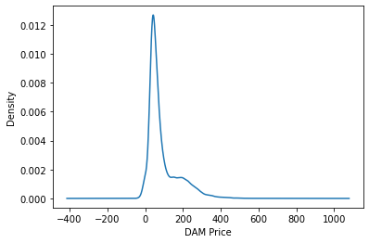

After Normalization of ‘EURPrices’ (DAM Price)

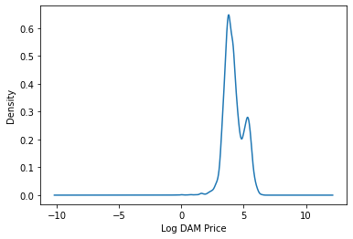

**CHAPTER 4**

**Energy Storage**

Wind was the second largest renewable source of energy after hydropower for power generation. However, since availability of wind is not consistent, wind farms are unable to produce as much as their capacity. Harnessing the wind power does not create any greenhouse gases. Electricity cannot be stored economically on a large scale and in appreciable quantities that would influence the operation of the power systems unless there is an increase in intermittent production from renewable energy sources.

*Energy storage* is the capture of energy produced at one time to use at a later time. Energy storage presents a more efficient and environment-friendly alternative. Without adequate energy storage, it is challenging to maintain an electricity grid’s stability which requires equating the energy supply and demand at every point of the day.[16]. The increasing penetration of renewable resources into the grid (transmission system) such as *wind and solar*, and their constant supply has benefitted the system with their short-run variability in the output and also reduced the cost of production but the timing of *potential arbitrage spreads* varies considerably day by day. The spread between daily peak and off-peak electricity prices depends in a multitude of factors: The difference in fuel costs of baseload and peak generation, the penetration of renewables and flexible technologies. Renewables like wind energy may affect the spread by reducing the prices when their output is high. [24]. Wind energy when coinciding with the peak demand can reduce the spread.

However, maintenance of frequency stabilization in the grid systems. Frequency Regulation is the major application in the Electricity Trading Market of the *Battery Energy Storage Systems* (BESS). [19]. The technology of BESS has developed rapidly in the last few decades. Storage generates revenue by arbitraging inter-temporal electricity price differences.

Decarbonizing the technology of Battery systems for electricity storage is the need of the hour for optimizing the arbitration process in the Electricity trading market. Batteries are often co-located with solar or wind facilities to avoid curtailment or are included in asset portfolios by TSOs.[16]. The *Battery Management System* (BMS) controls how the storage system will be used and a BMS that utilizes advanced physics-based models will offer a much more robust operation of the storage system.

As we have seen in figure 1.4 the DAM prices have been rising steeply from 2020 to 2022 while the day-ahead market prices reached their peak during the early quarter of the year 2022; Fig 2.1 and 2.2 shows that the wind forecast is on the higher side at the beginning of every year. This indicates that there are ample opportunities for the traders and battery and storage facilitators to explore the arbitrage spreads over the day-ahead markets. Storage that relies on daily arbitrage is susceptible to changes in daily spread.

In June 2021, Baringa released the article “*Endgame – A zero-carbon electricity plan for Ireland”* which projects up to 1,700 MW of large-scale battery storage system will be needed on an all-island basis to meet 2030 RES (Renewable Energy Resources) Energy targets and deliver a zero-carbon power system.[30 & 33].

**4.1 Arbitrage under Perfect and Imperfect Foresight**

Storage Technologies can reduce electricity prices through a process known as energy arbitrage by storing energy at low prices periods and discharging at a cheaper and cleaner alternative to fossil fuel generators in high price periods. [33] “*Arbitrage*” is the process of purchasing cheap off-peak electricity and selling it on-peak when the price is high; this is recognized as one revenue stream that will contribute to the business model.

Fig 4.1 shows a typical daily electricity profile with generation following the blue line to meet demand. Generally, the lowest demand periods are at night with a gradual ramp up in the morning and then a steep rise in the demand in the evening in line with the activities in the early night. Hence, the generation of electricity must meet the rise in demand with the most generation needed to meet the evening peak. This is the time in the intra-day market sees a spike in the electricity prices in the market as they are bought for just a couple of hours to meet the evening demand. (Ref: Fig 2.9)

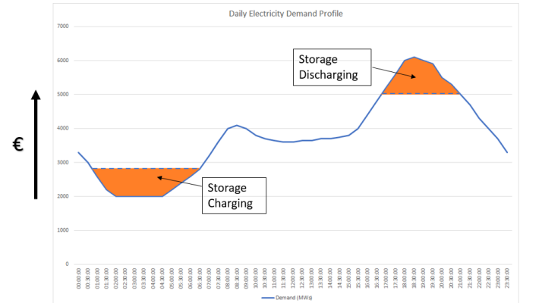

**Fig 4.1: Source: Article on Energy Storage Ireland “*Safety of Grid-scale Battery Energy Storage Systems”*[33]**

With battery energy storage systems introduced, charging batteries at low demand/price periods and discharging them at high demand/price periods, not only is a better alternative to the fossil fuels but also aids in smoothening the price volatility that we have seen in chapter 2 Fig 2.9 and Fig 2.10

It has been estimated that by 2050 deployment of energy storage could lead to savings of £10bn/year within the British Electricity system. Despite this accessing commercial rewards is challenging owing to the high sensitivity of arbitrage revenue to the round-trip efficiency of the storage technology in a large scale. Even with perfect foresight of electricity prices, profits may vary from year to year with variations of 50% and 75%. It is often speculated that commercial opportunities for storage will emerge as the penetration of intermittent renewables grows as it has the potential to increase price volatility.

The wind is attributed a marginal value equivalent to the opportunity cost of a Renewable Obligation Certificate (ROC) which has the effect of driving costs negative. There are multiple reserve scenarios, one of them which is most common is “Arbitrage under perfect and imperfect foresight or no foresight” of Future Market Prices and utilization of reserve. Perfect Foresight is the process to measure the maximum value obtainable from a Storage device while No Foresight accepts the Future prices and utilization volumes remain unknown and optimizes accordingly.[17].

The purpose is to find the optimal charge-discharge pairs coupled with discharging of batteries when the demand of energy is high or when the maximum price is occurring, at the same time charging when the prices are lowest and demand is low.

**4.2 Battery Energy Storage System**

Typically, a battery storage system is organized as follows:

* Individual battery cells are organised into modules
* Modules are mounted within the cabinet racks
* The racks are installed in a container

A storage system is made up of one or more alike containers and each container has an energy capacity of 1.5 MWh. These storage systems also have insulation, cooling systems, sensors and fire suppression installed. The *BESS* is controlled by the *BMS.*

**4.3 Features of Batteries:**

A study is necessary to understand the different battery storage technologies available in the market today with their specific and technical specifications. The size of the batteries are dependent on the discharge/charge cycle. The data has been obtained from paper [18] for battery system and types of battery storage systems. 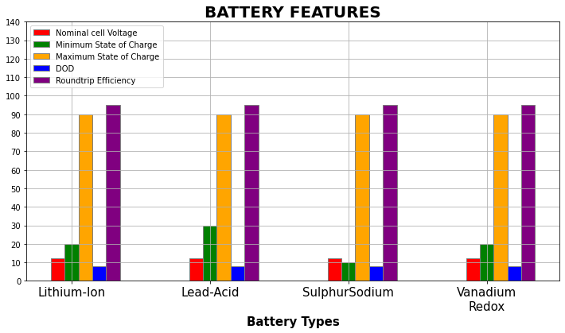

**Fig 4.2 Features of different types of Batteries**

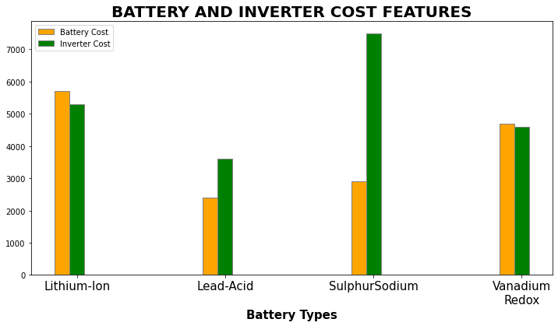

**Fig 4.3 Types of Batteries with respect to inverter cost**

*Round-trip efficiency*: It is measured as a percentage, is a ratio of the energy charged to the battery to the energy discharged from the battery.[27]. It can represent either DC-DC or AC-AC efficiency of the battery system, although AC-AC is more useful.[27]. The ‘Roundtrip” costs of the battery cycle include efficiency losses, degradation, trading and use of system costs and hence operators typically look for a safe expected margin above these before committing to an arbitrage trade.[16]

*Battery Lifetime and Life-cycle:* The most appropriate way of calculating a battery’s lifetime is to calculate the number of charge/discharge cycles over which the battery maintains a given fraction of its capacity.

*Charging and Discharging Rates:* The capacity of the battery is calculated as a function of the time in which the battery takes to fully discharge. The notation to specify the *battery capacity Cx*, where x is the time in hours that it takes to discharge the battery. C10=Z means that the battery capacity is Z when the battery is discharged in 10 hours. When the discharging rate is halved (and the time taken to charge is doubled i.e. 20 hours), the battery capacity rises to Y. [18]. The discharge rate when discharging the battery in 10 hours is found by dividing the capacity by time. Therefore, C/10 is the *‘Charge Rate’.* It can be also written as 0.1C. Consequently, for 20 hours is the charging time, the battery specification is denoted as *C20/10(0.1C20*). Batteries are charged when the demand is low and discharged only to remove the peaks of the load.

Each battery type has a set of limitations and conditions related to charging and discharging. For example, Nickel Cadmium batteries should be nearly completely discharged before charging while Lead acid batteries should never be fully discharged. In addition to that, the *voltage* and *current* during the charge cycle will be different for each type of battery.

*Nominal Cell Voltage:* The average voltage a cell outputs when charges

*Depth of Discharge (DOD):*In many types of batteries, the full energy stored in the battery cannot be fully discharged without causing serious, often irreplaceable damage to the battery. The Depth of Discharge determines the fraction of power that can be withdrawn from the battery as shown in Fig 4.4 below. For example, if DOD of a battery is 25% as quoted by manufacturer, then only 25% of the battery capacity can be used by the load.[17] Say a 500Ah battery with a DOD of 25% can only provide 500Ah*0.25=125Ah.

Sometimes, the manufacturers also specifically provide daily DOD. The Daily Depth of Discharge determined the maximum amount of energy that can be extracted from the battery in as 24-hour period.

DoD= * 10

For grid-connection applications, it would be extremely rare for a battery to experience a deep discharge (80-100% of discharge). This type of duty is not likely to impact the life of the battery.[16]

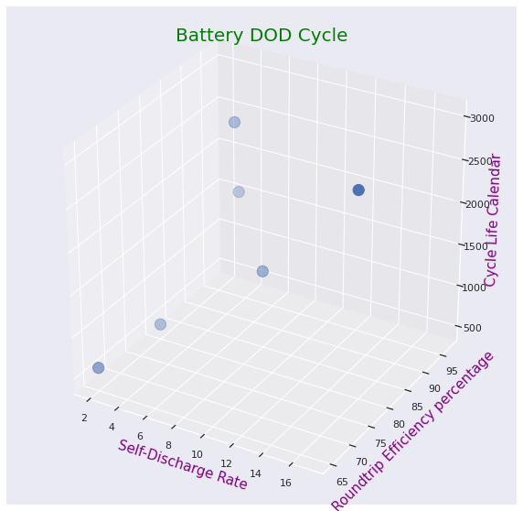

**Fig 4.4 Battery DOD Cycle**

We will here discuss the types of batteries used in Battery Energy Storage systems such as lead-acid, Lithium-nickel-cadmium (LiNCM), sodium-sulfur (Na-S) batteries, Lithium-ion and Vanadium redox flow batteries.

* Lead -Acid batteries are good round-trip efficiency (75-80%), with high power density, low cost however the lead-acid batteries have low life cycle.[18]
* Ni-Cd Batteries have long life cycle, low maintenance and light weight but their major disadvantage is limited energy density and high cost which makes it difficult to use on a large-scale basis.
* Na-S batteries have a high energy density, long life-cycle and high self-discharge resistance. The only major disadvantage is High cost
* Vanadium Redox is water based, non-flammable
* Lithum-ion batteries: Some researchers tried to extend the life of the battery, which can significantly reduce the batteries’ costs, and studied the life of the widely used Li-ion battery. These batteries are considered to be the most promising types of grid-scale energy storage and a recent forecast from *Bloomberg New Energy Finance* estimated that the Global Energy Market is expected to attract *$620 Billion* in investment over the next 22 years. [22]. It is also projected that Global Energy Storage deployments will grow thirteenfold over the next 6 years from a *12* *GWh* Market in 2018 to a *158* *GWh* market in 2024.

Reasons why Lithium-ion batteries have been used widely for the last 50 years [33] :

1. The Lithium-ion batteries have been used in over 8.7 million fully battery-based Electric and Plug-in Hybrid Cars, 4.68 billion phones, and 12 GWh of Lithium-ion grid-scale battery storage systems (equivalent to a further 1.2 billion iPhones) being used safely around the world. Grid-scale Lithium-ion batteries have a slightly different composition than those used in consumer electronics products.
2. The lithium-ion batteries have dense energy [33], meaning they can hold large amounts of energy relative to their size.
3. These batteries can handle hundreds of charge/discharge cycles
4. Cost-effective and easily available
5. Improved system control, power quality and reliability
6. System Balancing
7. More efficient use of Power Generation plant

They used a lithium phosphorous oxynitride (LiPON) layer to extend at least 10 years of storage life and improve capacity retention during storage ageing at elevated temperatures. The stability of LiO2 battery which emphasized the importance of proper discharge/charge rate and the discharge depth for the other cathode /electrolyte combinations to improve the life-cycle performance of the battery. [32]

**Conclusion**

Negative pricing is an issue that not only is faced by Ireland, but is also a common occurrence in European markets. [34]. Today, Battery Energy Storage Technologies present a greener (no carbon emission), voltage and frequency regulated approach for stabilising electricity prices in the Day-Ahead Trading market, enhance power system flexibility and enable high levels of renewable energy integration. [27].

As per Europe’s plan to cut emissions by at least 55% by 2030, wind electricity is predicted to be at 70% of the demand forecast (as mentioned in chapter 2), the model’s prediction success will be measured mainly by the following:

* The most relevant metric for this work is the Mean Absolute Error (MAE) as absolute values are what we are trying to measure in order to recommend when to charge batteries to maximize profits for market participants.
* Exact Forecasting is extremely important as to know when the proportion of actual wind generation is high, as when the wind is low the electricity carbon intensity will be high which is not desirable.
* The R-squared and variance regression score is also calculated from the models for better understanding of the model limitations and performance. We have seen the limitations of R-squared metric, as we have statistically significant variables (p-value<0.05) which shows that the Regression model might predict correct values. If we select the parameters (βs) carefully, we will be able to reduce the difference between the actual and predicted values and thus resulting in a good model.

Arbitraging systems provide an optimal solution to beat the sudden spikes in demand of power and electricity price rising and also putting the Renewable Energy Resources (RES) to maximum use and thus **reducing renewable energy curtailment**.[27]. We will be able to correctly predict the Prices with the model and let the batteries charge at the peak-shaving period and discharge during the peak hours to meet the peak demand leading to smooth operation of demand-supply of power with a guarantee for safety and reliability of BESS.

**References**:

[1] I-SEM – The Utility Regulator (Electricity, Gas, and Water)

[I SEM | Utility Regulator (uregni.gov.uk)](https://www.uregni.gov.uk/i-sem)

[2] Cashman, D. (2021). Prepare for wholesale changes in the Irish Electricity Market,

[I-SEM - Prepare for wholesale changes in the Irish Electricity Market | EY Ireland](https://www.ey.com/en_ie/power-utilities/i-sem-prepare-for-wholesale-changes-in-the-irish-electricity-market)

[3] SEAI, Sustainable Energy Authority of Ireland; EirGrid;

[Electricity | Monthly Energy Data For Ireland | SEAI](https://www.seai.ie/data-and-insights/seai-statistics/monthly-energy-data/electricity/)

[4] Supervised Learning using scikit-learn

[1. Supervised learning — scikit-learn 1.1.2 documentation](https://scikit-learn.org/stable/supervised_learning.html#supervised-learning)

[5] Renewable Energy; <https://www.c2es.org/content/renewable-energy>

[6] Ahmad M.W.; Mourshed M.; Rezgui Y. (**2018**). Tree-Based Ensemble methods for

Predicting PV Generation and their comparison with Support Vector Regression;

[Tree-based ensemble methods for predicting PV power generation and their comparison with support vector regression - ScienceDirect](https://www.sciencedirect.com/science/article/pii/S0360544218317432)

[7] The Integrated Single Electricity Market Project, [I-SEM (eirgridgroup.com)](https://www.eirgridgroup.com/customer-and-industry/i-sem/)

[8] SEM Committee – The Decision-making authority for the Single Electricity Market on the

The Island of Ireland. [How the SEM works | SEM Committee](https://www.semcommittee.com/how-sem-works)

[9] Time-series parsing for time-series data analysis with Pandas and Python

[Timestamp parsing for time-series data analysis with Pandas and Python| by Sudeep Gowrishankar | Towards Data Science](https://towardsdatascience.com/timestamp-parsing-with-python-ec185536bcfc)

[10] The Erid Group, The Current, The Future,2016

*Quick Guide to the Integrated Single Electricity Market, The ISEM Project (Version 1)*

[ISEM quick guide_1.pdf (semcommittee.com)](https://www.semcommittee.com/sites/semc/files/media-files/ISEM%20quick%20guide_1.pdf)

[11] Singh N.; Mohanty S.R., “*A Review of Price Forecasting Problem and Techniques*

*in Deregulated Electricity Markets*,” J. Power Energy Eng., vol. 3, no. September,

pp. 1–19, 2015, [10.4236/jpee.2015.39001](http://dx.doi.org/10.4236/jpee.2015.39001)

[12] Seaborn Statistical Library

[seaborn: statistical data visualization — seaborn 0.11.2 documentation (pydata.org)](https://seaborn.pydata.org/#:~:text=Seaborn%20is%20a%20Python%20data,introductory%20notes%20or%20the%20paper.)

[13] Wirdemo, A.;The Impact of Wind Power Production on Electricity Price Volatility. (2017)

[FULLTEXT01.pdf (diva-portal.org)](https://www.diva-portal.org/smash/get/diva2:1128192/FULLTEXT01.pdf)

[14] Reiner A.C. van der Veen; Rudi A.Hakvoot; The Electricity Balancing Market: Exploring the design challenge, Utilities Policy (**2016**). Volume 43, Part B,186-194

<https://www.sciencedirect.com/science/article/pii/S0957178716303125>

[15] Supply, Demand and Market Equilibrium

[Negative prices for electricity - Florence School of Regulation (eui.eu)](https://fsr.eui.eu/negative-prices-electricity/)

[16] Abramova E.; Bunn, D. (2021)

*Energies:* [*Optimal Daily Trading of Battery Operations Using Arbitrage Spreads*](https://arxiv.org/ftp/arxiv/papers/2108/2108.13511.pdf)

[17] [Staffell](https://www.sciencedirect.com/author/23101313800/iain-staffell), I.; [Rustomji](https://www.sciencedirect.com/science/article/pii/S2352152X1630113X#!), M. [Maximizing](https://www.sciencedirect.com/science/article/pii/S2352152X1630113X) the value of electricity storage, J. of Energy

Storage, (**2016**), Vol. 8, 212-225

[18] Mehdijev, S.;Dimensioning and Life Cycle Costing of Battery Storage System in

Residential Housing: A Case study of Local System operator, 2017.

[MergedFile (diva-portal.org)](https://kth.diva-portal.org/smash/get/diva2:1130036/FULLTEXT01.pdf)

[19] [Nitsch, F.;](https://www.sciencedirect.com/science/article/pii/S0306261921006851" \l "!) Diessenroth-Uhrig, M.; [Schimeczek](https://www.sciencedirect.com/science/article/pii/S0306261921006851#!), C.; [Bertsch](https://www.sciencedirect.com/science/article/pii/S0306261921006851#!) V.; Economic Evaluation

of battery storage systems bidding on day-ahead and automatic frequency restoration

reserves market. (2021). Applied Energy. Vol. 298.

<https://doi.org/10.1016/j.apenergy.2021.117267>

[20] European Electricity Day-Ahead Markets: A Review of Models and Solution Methods,

Tanrisever, F.;Shahmanazari, M.;Buke, B. & EPEXSPOT 2019.

[21] Derinkuyu, K.; Tanrisever, F.;Kurt, N. & Ceyhan, G.(2020), Optimizing Day Ahead

Electricity Market Prices: Increasing the Total Surplus for Energy Exchange Istanbul, *Manufacturing & Service Operations Management*, 22(4),700-716

[22] Bloomberg NEF (2018)

[Energy Storage is a $620 Billion Investment Opportunity to 2040 |BloombergNEF (bnef.com)](https://about.bnef.com/blog/energy-storage-620-billion-investment-opportunity-2040/)

[23] Negative Power Pricing peaks Europe during coronavirus

<https://www.windpowermonthly.com/article/1696090>

[24] F. Sensfuß, M. Ragwitz, M. Genoese, The merit-order effect: a detailed analysis of the

price effect of renewable electricity generation on spot market prices in Germany,

Energy Policy 36 (2008) 3086–3094, doi: <http://dx.doi.org/10.1016/j.enpol.2008.03.035>

[25] [Lago, J.;](https://www.sciencedirect.com/science/article/pii/S0306261921006851#!) Marcjasz, G.; Shutter, B.D.; Weron, R. Forecasting Day-ahead electricity

prices: A Review of state of the Art Algorithms, best practices and an open-access benchmark (2021). Applied Energy. Vol. 293.[1]

[26] [How to Create an ARIMA Model for Time Series Forecasting in Python?](https://www.analyticsvidhya.com/blog/2020/10/how-to-create-an-arima-model-for-time-series-forecasting-in-python/)

[27] Thomas, B.; Chernyakhovskiy, I.; Denholm, P.; National Renewable Energy Laboratory;

Grid-Scale Battery Storage (2017); https://www.nrel.gov/docs/fy19osti/74426.pdf

[28] Peshawa J. Muhammad Ali, Rezhna H. Faraj; “Data Normalization and Standardization:

A Technical Report”, Machine Learning Technical Reports, 2014, 1(1), pp 1-6. [https://docs.google.com/document/d/1x0A1nUz1WWtMCZb5oVzF0SVMY7a_58KQulqQVT8LaVA/edit#](https://docs.google.com/document/d/1x0A1nUz1WWtMCZb5oVzF0SVMY7a_58KQulqQVT8LaVA/edit)

[29] [ambujmishra0008/Wind-Energy-Scenario-Generation-Using-ARIMA-Model](https://github.com/ambujmishra0008/Wind-Energy-Scenario-Generation-Using-ARIMA-Model)

[30] Baringa: [Endgame - A zero-carbon electricity plan for Ireland (baringa.com)](https://www.baringa.com/BaringaWebsite/media/BaringaMedia/PDF/20210629-Baringa-Endgame-Final-Version.pdf)

[31] Calculating skewness and Kurtosis in Python [How to Calculate Skewness and Kurtosis in Python? (turing.com)](https://www.turing.com/kb/calculating-skewness-and-kurtosis-in-python)

[32] Dong, Y.; Zhao, T.; Ding, Z. An optimal Day-ahead Bidding Strategy and Operations for

Battery Energy Storage System by Reinforcement Learning (2020)

<https://doi.org/10.1016/j.ifacol.2020.12.144>

[33] Safety of Grid-Scale Battery Energy Storage Systems; Energy Storage Ireland,

*Information paper;*

[Energy Storage Ireland Information Paper on the Safety of Grid-Scale Battery Energy Storage Systems](https://www.energystorageireland.com/wp-content/uploads/2021/08/ESI-Information-Paper-on-the-Safety-of-Grid-Scale-Battery-Energy-Storage-Systems-July-2021.pdf)

[34] [Avoiding negative electricity prices: what measures should TSOs take?](https://www.eca-uk.com/2019/03/14/avoiding-negative-electricity-prices-what-measures-should-tsos-take/) (2019)

Economic Consultants Associates Ltd.